**CPSC1517 Exercise 01**

**Purpose**

To practice how to use Razor to create an ASP.NET Layout Page and how to create ASP.NET Content Pages that uses a layout page.

**Description**

The web pages you will created in exercises 1-4 will have a consist layout, a navigation menu to switch between the different pages and a basic form.

In this exercise you will create:

* an ASP.NET Layout Page with a common layout for all pages and a common navigation menu for all pages.
* a basic 2 column form which will contain a textbox and a checkbox list.
* The necessary code to process the form on a post back.

**Resources**

[Creating a Consistent Layout working Bootstrap](http://getbootstrap.com/css/#overview)

**Setup**

1. Open your Visual Studio software.
2. Create an new empty solution. Select **File/New/Project.** Choose **Template/Other Project Types/Visual Studio Solutions, Blank Solution.** Name your solution ***Razor*Solution**. Choose a convenient location or where your instructor specifies.
3. Open your Solution Explorer of your new empty solution; right click on your solution name and **ADD/New Project.** Select **Visual C#, Web, Asp.Net Web Application** **(.Net Framework)**. Name your web application ***firstinitiallastnameWebApp*** where ***firstintiallastname***is your first and last name (example Pat Smith would create PSmithWebApp)**.** Press **OK.** Select Empty and press Ok.
4. Add a new folder to your webApp called **ExercisePages**.
5. Right click on your website name and select **Manage NuGet Packages… Select Online. Install the following packages:**a) Microsoft.ASPNet.Razor

b) Microsoft.ASPNet.WebPages  
c) Microsoft.ASPNet.WebPages.Data  
d) Microsoft.ASPNet.WebPages.WebData  
e) Bootstrap (version 3.3.7)   
f) Update jQuery to 3.3.1 version.

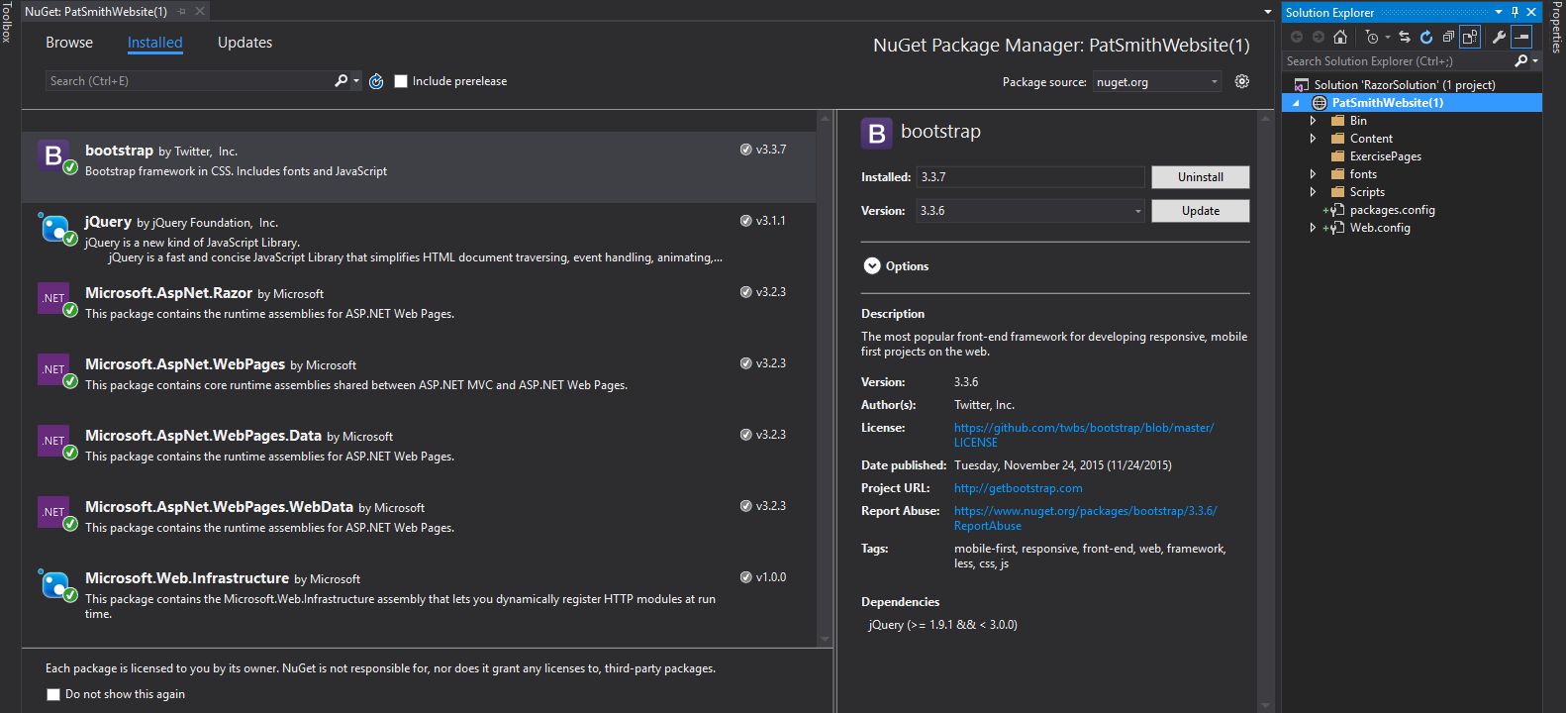

**Creating a Consistent Layout**

1. Add a new layout.cshtml page at the root of your web application. Right click on your webapp name, select **Add/New Item**. Search for layout and select Layout Page (Razor v3) and use _Layout.cshtml as the name.
2. Use the code in your classroom examples to alter the _Layout.cshtml file.
   1. Create a menu that has a menuitem to the Home page and to your Exercise 01 page. Your Home page link may be on the menu brand or a separate menu item. Place your Exercise page in a sub menu. You will be adding additional pages for exercises 2-4 to this submenu.
   2. Add the following links and scripts to the top of the <head>

<script src="~/Scripts/jquery-3.3.1.js"></script>

<link href="~/Content/bootstrap.css" rel="stylesheet" />

<script src="~/Scripts/bootstrap.js"></script>

* 1. Add a RenderSection under your menu that will use the jumbotron Bootstrap class. This section is to be called **pagetitle**. It is to be required. This section will display on all exercise pages.

1. Create a Content page called **index.cshtml** from Add New Item/ MVC5 View Page with Layout (Razor) at the root of your web application. Add the Page.Title to **Home**. Activate and set the layout page to _Layout.cshtml created in step 1. Put your first name, last name, email and appropriate logon id (as specified by your instructor) in the section pagetitle on this page. **Set this page as your webapp start up page**.

**Create and Process a Basic Form**

You will create a simple form and process the post back using C# via Razor. You will use some formatting features of Bootstrap on the form. The form (shown below) will contain a text box and a checkbox selection list in a 2 column form using bootstrap for formatting. When you press Submit, your form will display the entered and selected data/choices.

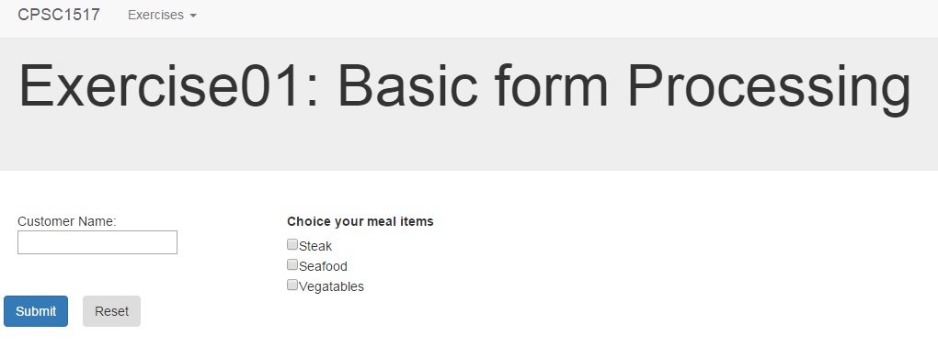

Create the form

1. Create a new Content Page (Razor v3) page called **Exercise01.cshtml** in the folder **ExercisePages**.
2. Add the page title **Exercise01** and set up Layout to your layout page. Add a **@section pagetitle{ Exercise01: Basic Form Processing }.** Add a <div> tag.
3. Alter your menu in the menu location in **_Layout.cshtml.** Add a menuitem to the submenu for **Exercise01.cshtml**.
4. Create a form on Exercise01.cshtml with an id of **EX01,** method of post.
5. Within this <form> tag create 2 more <div class-“row”> tags.
6. Within the first **<div class-“row”>** create 2 more **<div>**. The first **<div>** will span 3 medium bootstrap columns and the second 9 bootstrap columns. ([Creating a Consistent Layout working Bootstrap](http://getbootstrap.com/css/#overview))
7. In the first column add a text for your label (do not use the **<Label>** tag): Customer Name and a **<input>**. Add a value=’’@.....” to the **<input>** so that input will be retained on posts. You will need to add a variable to your form code processing to handle the value parameter in the **<input>** tag.
8. In the second column use a **<Label>** tag to add the title Choose your meal items. Add **at least 3** meal items as a set of checkboxes.
9. Add two **<input>** tags of **type**: submit; **class**: btn; and **value** of submit and reset respectively. Make the submit button the primary button. **DO NOT** use type: reset.
10. Save and view your page.

Code the form processing logic.

Code the necessary logic to process this form. Your logic will need to:

1. Retrieve the values from your various form tags.
2. If the reset button was pressed, set the value for your customer name to nothing.
3. If the submit button was pressed:
   1. Check that a customer name was entered. If not display a message.
   2. Check that a meal selection was made, if not display a message.
   3. If A and B are valid, display a message containing the customer name and a bulleted containing the selected meal items.

**Submission.**

Once you have completed the exercise, you **must** demonstrate your work to you instructor **in class.** You instructor **may**instruct you to submit the completed work to a secondary location such as your class moodle site, github repository or to your P: drive drop box. **This exercise is either evaluated as complete or incomplete**.

**Sample processing images.**

You may customize the processing messages to suit your own content.

